Who Am I?

Name: ______________________________________

Step 1: Who am I? The Foundation Skills

A. Brainstorm:
Key your thoughts to the following questions about YOU! Include a minimum or 2-3 sentences or 3-5 words.

What do I like to do? (Think about experiences you have enjoyed. What kind of school, religious, social or sports activities you like to do) | 2. What are your talents, hobbies and/or abilities? | 3. What do other people say you are good at doing?
4. What subjects at school do you like? What clubs or organizations do you belong to? | 5. What do you like to do in your free time? (Have you volunteered, worked jobs in the neighborhood…) | 6. Which skill areas describe you the best? Click these links and jot down (copy and paste) a few which describe you.

B. Foundation Skills:
Next, visit the Career Key website and copy/past a minimum of 2-3 sentences or 3-5 words that describe you for each skill-set. http://www.careerkey.org/asp/career_development/foundation_skills.html
(Lawrence K. Hones, Ph.D., NCC)

Basic Skills | Thinking Skills | People Skills | Personal Qualities
Step 2: Holland’s Code Quiz
Using the link to the Holland Code, complete the quiz and paste the screen shot of your results below.

A. Take the Holland Quiz
Complete the quiz online or on paper.

To Take the Online Quiz
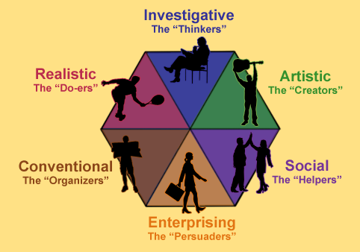
Click this link or key the following link into your Internet browser to take the quiz online
http://www.roguecc.edu/Counseling/HollandCodes/test.asp

OR

To Complete using a Paper Copy
Click this link to download the paper version or key the following link into your Internet browser to download the paper copy
http://21things.foxbrightcms.com/downloads/career_prep/know-your-personality-type.pdf

B. Screenshot your results.
After taking the quiz, do a screenshot of the results. Paste below:

C. Review the example and interpret your results.
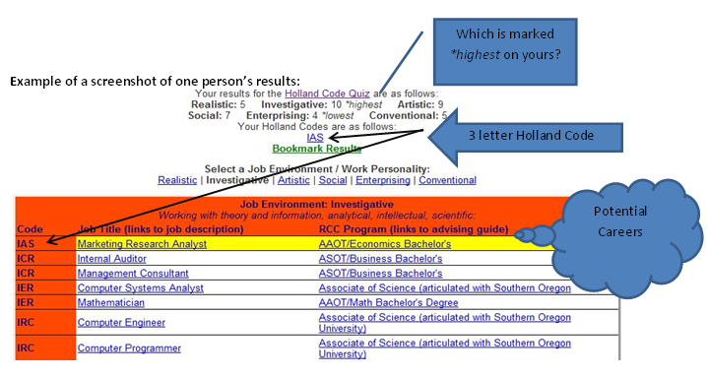

What is your highest area: _____________________________

What is your 3 letter Holland Code: ________________

D. Identify three potential careers

Clicking on the “Job Title” will take you to information about the median salary, required education, and Job outlook. *Some do not have this information available.

Here is an example:
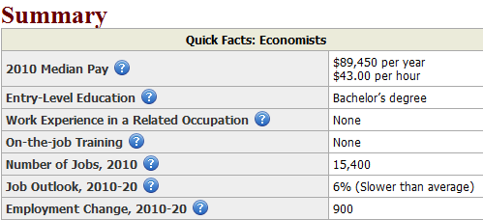

Capture three screenshots of three potential careers.

Screenshot Potential Career 1:

Screenshot Potential Career 2:

Screenshot Potential Career 3:

Step 3: Capture Words that Describe You!

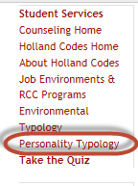
- Visit “Personality Typology” to review the description of your personality Type
http://www.roguecc.edu/Counseling/HollandCodes/personality.asp

Key or copy/paste a few words to describe your personality/you from your visit to the link above:

Attribute | Description
Preferences for activities and occupations
Values
Sees self as
Others see you as
Avoids

B. Visit “Job Environments/Work Personality” to find out more about the job titles (with links to job descriptions) and college programs (and links to courses) at:
http://www.roguecc.edu/Counseling/HollandCodes/codes.asp

- Begin by clicking on your Job Environment/Work Personality.
- Click on the job title to see links to the job description
- Click on the RCC Program to see examples of courses and degrees for this job.

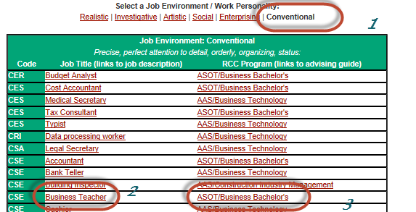

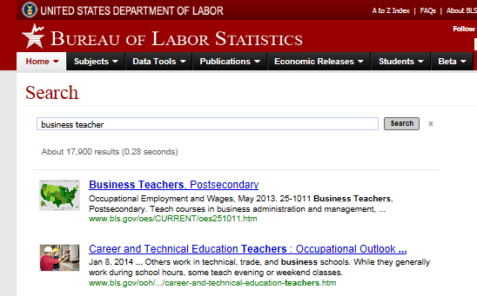
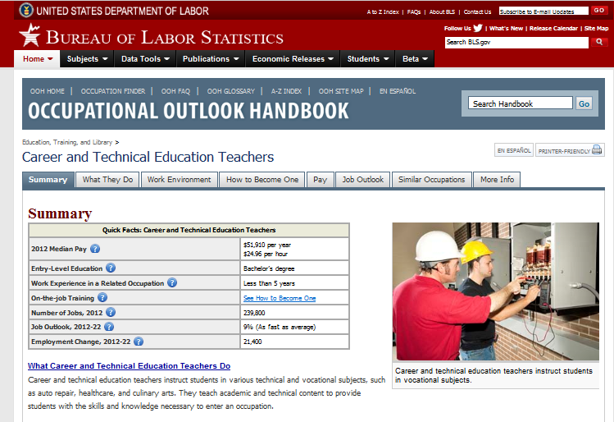
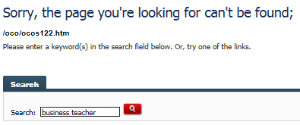
If you get no results, key the job title in the Search box. Click on the hyperlink in the list of “hits” that takes you to the Occupational Outlook Handbook for your chosen career.
Key at least 2-3 ideas for each of the following categories after your exploration of the Holland Code Personality links:

I like to: | Possible Majors: | Possible Careers: | Possible College Campus Activities: (you may substitute with school activities)
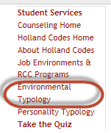
C. Visit “Environmental Typology” to find out about the work environment for the types of jobs within your Personality type.
http://www.roguecc.edu/Counseling/HollandCodes/environment.asp
Review the categories for your Personality Type.

Key or copy/paste a few words to describe your personality/you from your visit to the link above:

Attribute | Description
Demands and rewards the display of…
Values or personal styles allowed expression
Occupations or other environments involve
Sample Occupations
Step 4: Create a Personality Map
- Using at least 10 words from steps 1-3, create a mind map or word cloud of your personality and interests.
- Paste the image/screenshot below (suggested tools: Bubbl.us, Wordle.net, Tagxedo.com)

Insert Personality Map:

Step 5: Post to your online presence

What is the web address for your online presence where you posted your WhoAmI.doc:

_____________________________________________________________________________

